Canny:

<https://docs.opencv.org/master/da/d5c/tutorial_canny_detector.html>

**Back Projection:**

Take an image as the base image. Hue histogram of that image is taken. Now the back projection has to be done on the new image. Here in the new image the master image Hue matching pixels are turned white and rest are kept as black.

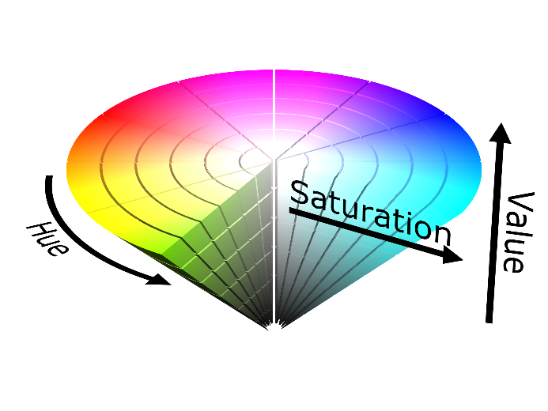 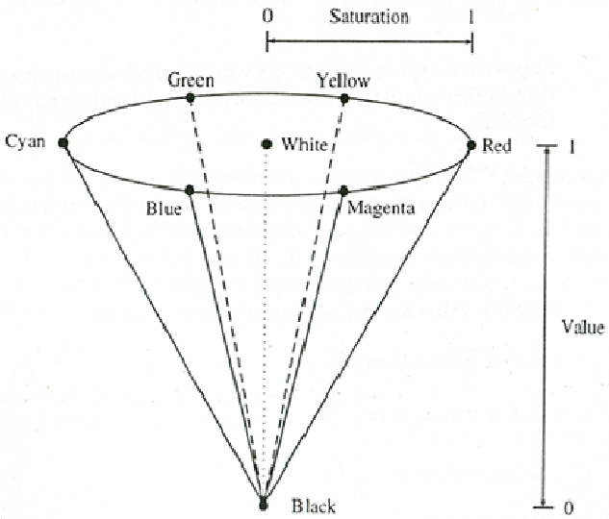

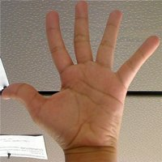 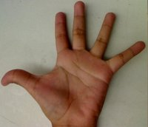 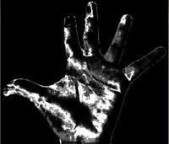

Master image Test image Result

<https://docs.opencv.org/master/da/d7f/tutorial_back_projection.html>

<https://www.youtube.com/watch?v=0rYtZtY5ML4&ab_channel=Pysource>

**Features2D + Homography to find a known object:**

1. Key points are detected
2. Matching of keypoints are done between the saved image and the present image. Here the number of keypoints can be set using a threshold.
3. A bounding box is drawn around the detected object.

<https://docs.opencv.org/master/d7/dff/tutorial_feature_homography.html>

**Back Ground subtraction:**

1. Current frame is subtracted either from the previous frame or with the master image.
2. This will result in detecting moving objects in the frame
3. Erosion, dilation, erosion can be used to remove noise from images.

<https://docs.opencv.org/master/d1/dc5/tutorial_background_subtraction.html>

**Optical flow:**

1. Motion of object between 2 different frames is detected.
2. This is done by tracking keypoints over a period of 5 frames. If the same matching keypoint is not detected then the next closest keypoint is considered.
3. Optical flow works on the flowing assumptions. The pixel intensities of an object do not change between consecutive frames.
4. Neighboring pixels have similar motion.

<https://docs.opencv.org/master/d4/dee/tutorial_optical_flow.html>

**Harr-Cascade:**

<https://docs.opencv.org/master/db/d28/tutorial_cascade_classifier.html>

<https://docs.opencv.org/master/dc/d88/tutorial_traincascade.html>

Camera calibration:

<https://docs.opencv.org/master/d4/d94/tutorial_camera_calibration.html>